Satellite Antenna Tracking Mount

Hunter Britton

Michael Raabe

David Santos

**Functional System Requirements**

REVISION – 1.0

16 February 2023

Functional System Requirements

for

Satellite Antenna Tracking Mount

Approved by:

_____________________________

Hunter Britton Date

_____________________________

Prof. S. Kalafatis Date

_____________________________

Pranav Dhulipala Date

**Change Record**

| **Rev.** | **Date** | **Originator** | **Approvals** | **Description** |
| --- | --- | --- | --- | --- |
| **1.0** | 2/15/2023 | David Santos |  | Draft Release |

**Table of Contents**

**1. Introduction** **7**

1.1. Purpose and Scope 7

1.2. Responsibility and Change Authority 8

**2. Applicable and Reference Documents** **9**

2.1. Applicable Documents 9

2.2. Reference Documents 9

2.3. Order of Precedence 9

**3. Requirements** **10**

3.1. System Definition 10

3.1.1 Web App Hosting 11

3.1.2 Web App Framework 12

3.1.4 Microcontroller 12

3.1.5 Power Supply 12

3.2. Characteristics 12

3.2.1. Functional / Performance Requirements 12

3.2.1.1 Signal Strength and Quality 12

3.2.1.2 Azimuth and Elevation Accuracy 12

3.2.1.3 Tracking Speed 12

3.2.2. Physical Characteristics 13

3.2.2.1 Form Factor 13

3.2.2.2 Weather Resistance 13

3.2.3. Web App Requirements 13

3.2.3.1 Interactive Map 13

3.2.3.2 Satellite Selection 13

3.2.3.3 Rotator Connection Port 13

3.2.4. Electrical Characteristics 13

3.2.4.1 Inputs 13

3.2.4.2 Power Consumption 14

3.2.4.3 Input Voltage Level 14

3.2.4.4 Input Noise and Ripple 14

3.2.4.5 External Commands 14

3.2.5 Outputs 15

3.2.5.1 Data Output 15

3.2.5.2 Diagnostic Output 15

3.2.5.3 Connectors 15

3.2.5.4 Wiring 15

3.2.6 Failure Propagation 16

3.2.6.1 Failure Detection, Isolation, and Recovery (FDIR) 16

3.2.6.2 Built In Test (BIT) 16

3.2.6.3 BIT Critical Fault Detection 16

3.2.6.4 BIT Log 16

**4. Support Requirements** **17**

**Appendix A: Acronyms and Abbreviations** **18**

**Appendix B: Definition of Terms** **19**

**List of Tables**

**Table 1. Subsystem Responsibility**

**Table 2. Standards**

**Table 3. Reference Documents**

**List of Figures**

**Figure 1.** **Browser-Based Satellite Antenna Tracking System** **1**

**Figure 2. System Block Diagram** **4**

# 

# Introduction

## Purpose and Scope

This document provided detailed system requirements for a amateur radio remote operation system. Amateur radio systems require specialized equipment and software to operate automatically. Typically a controller is used in conjunction with computer software to control the antenna rotator, but our objective is to provide a remote operation system that will allow a user to control the antenna from a web browser. The Satellite Antenna Tracking Mount (SATM) will be formed from a legacy rotator with two motors, additional control and communication hardware, and a web application. SATM will also display pertinent data and provide secure user authentication via hashing account data, allowing for low-cost remote operation. The improved system will provide users greater flexibility and ease-of-use through web accessibility.

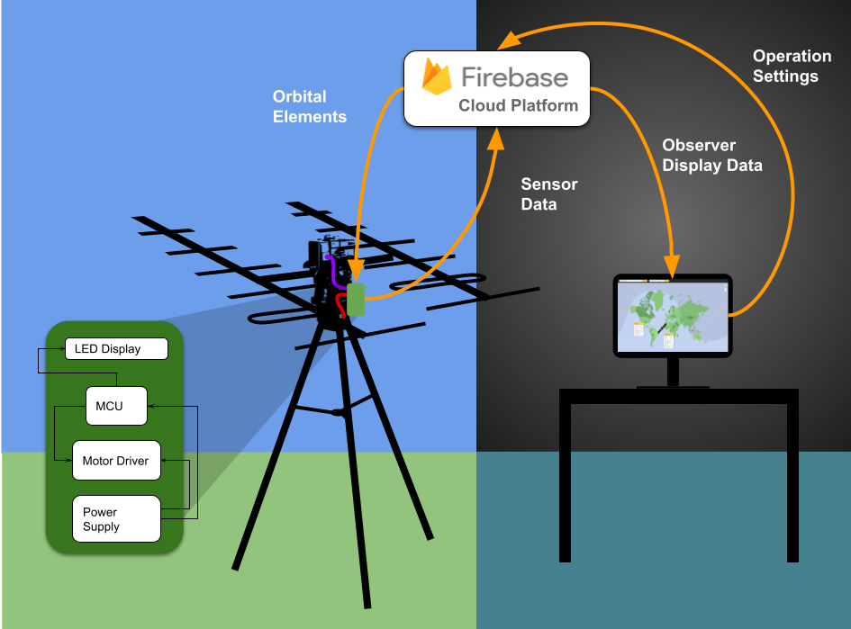

**Figure 1. Browser-Based Satellite Antenna Tracking System**

The following definitions differentiate between requirements and other statements.

Shall: This is the only verb used for the binding requirements.

Should/May: These verbs are used for stating non-mandatory goals.

Will: This verb is used for stating facts or declaration of purpose.

## Responsibility and Change Authority

The team leader, Hunter Britton, will be responsible for verifying all requirements are satisfied and the verification plan. Performance requirements are only to be changed by David Gent or by the consensus of the team members with the approval of David Gent. Each owner is responsible for the fulfillment of the functional requirements for their subsystem shown below.

**Table 1. Subsystem Responsibility**

| **Subsystem** | **Owner** |
| --- | --- |
| MCU / IO | Hunter Britton |
| Power Supply / Motor Driver | Michael Raabe |
| Web Application | David Santos |

# Applicable and Reference Documents

## Applicable Documents

The following documents, of the exact issue and revision shown, form a part of this specification to the extent specified herein:

**Table 2. Standards**

| **Document Number** | **Revision/ Date** | **Document Title** |
| --- | --- | --- |
| IPC A-610E | Revision E – 4.1.2010 | [Acceptability of Electronic Assemblies](https://www.ipc.org/TOC/IPC-A-610E.pdf) |
| IEEE 802.11ba | Revision ba - 2021 | [Wake-Up Radio Operation](https://ieeexplore.ieee.org/document/9570110) |
| CCSDS 502.0-P-2.1 | Revision 2.1 - 10.21 | [Orbit Data Messages](https://cwe.ccsds.org/moims/docs/MOIMS-NAV/Draft%20Documents/Orbit%20Data%20Messages%20(ODM)/ODM-agency-review-502x0p2.1.pdf) |
| FCC 97.213 | Revision 213 - 6.20.1989 | [Telecommand of an Amateur Station](https://www.law.cornell.edu/cfr/text/47/97.213#:~:text=CFR-,%C2%A7%2097.213%20Telecommand%20of%20an%20amateur%20station.,to%20perform%20his%2Fher%20duties.) |

## Reference Documents

The following documents are reference documents utilized in the development of this specification. These documents do not form a part of this specification and are not controlled by their reference herein.

**Table 3. Reference Documents**

| **Document Number** | **Revision/ Date** | **Document Title** |
| --- | --- | --- |
| CFR P97T47 | 6.20.1989 | [Amatuer Radio Service](https://www.ecfr.gov/current/title-47/chapter-I/subchapter-D/part-97) |
| C95.6 | 10.23.2022 | [IEEE Standard for Safety Levels With Respect to Human Exposure to Electromagnetic Fields](https://ieeexplore.ieee.org/document/8859679) |

## Order of Precedence

In the event of a conflict between the text of this specification and an applicable document cited herein, the text of this specification takes precedence without any exceptions.

All specifications, standards, exhibits, drawings or other documents that are invoked as “applicable” in this specification are incorporated as cited. All documents that are referred to within an applicable report are considered to be for guidance and information only, except ICDs that have their relevant documents considered to be incorporated as cited.

# Requirements

This section defines the minimum requirements that the development item(s) must meet. The requirements and constraints that apply to performance, design, interoperability, reliability, etc., of the system, are covered.

## System Definition

The SATM system is divided into three subsystems to manage complexity: microcontroller and peripherals, power supply and motor driver, and web application interface. The microcontroller is responsible for taking data from the rotator motors, GPS, and web application settings and using it to control the LED display, antenna positioning, and relaying that back to the web application with a WiFi module. The power supply subsystem will convert power from the standard wall outlet 120v 60Hz to power the motor driver and microcontroller. Finally the web application will be used to interface with the rotator through the Firebase platform. The web application will feature search capabilities for the rotator and satellite, data visualization, and a map visualizer.

A user will first connect their rotator via Wifi. The web app will then request GPS location, as well as the current position of the antenna from the microcontroller to determine where to place the marker on the map. Once a satellite is selected, the web app will access the NASA satellite catalog to relay the orbital elements. The microprocessor can then calculate the path of the satellite as well as the motor controls. Alternatively, the user can choose to manually enter the elevation and azimuth positioning.

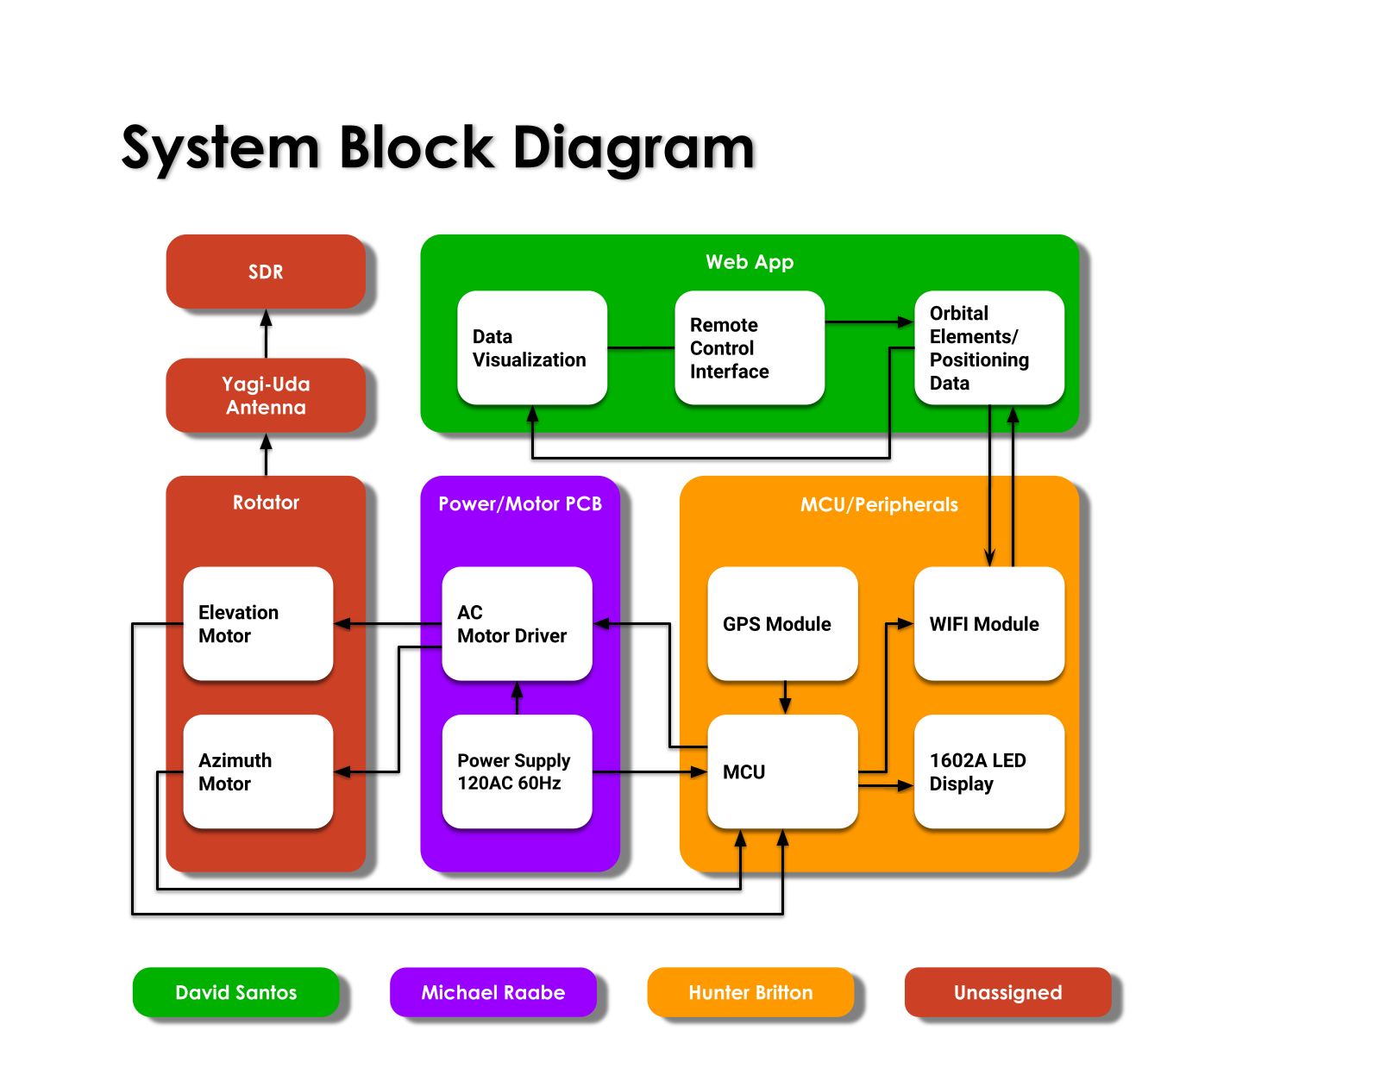

**Figure 2. System Block Diagram**

The block diagram in Figure 2 illustrates the subsystem added to legacy systems as well and their sub components. The MCU acts as an intermediate controller between the web application and rotator system. This PCB along with the power supply and driver will be mounted onto the upper part of the rotator with enough slack that it can move freely.

#### 3.1.1 Web Application Hosting

Firebase is a collection of web services developed by Google and will serve as the web application hosting platform. Similar to Amazon Web Services (AWS), it provides functions typically handled by the server, such as real-time databases and user authentication, through the cloud. It was designed to enable rapid prototyping and scalability, making it perfect for IoT applications that use web hosting. Firebase works on multi-tier payments to cater to the diverse users, ranging from hobbyists to professionals.The “Spark Plan” is the free version and provides all the necessary features for this project with the option to upgrade. Firebase incorporates the REST API, which is a software architecture that uses HTTP requests, such as “GET”, “POST”, “PUT”, and “DELETE”, to interact with resources on the server. HTTP can use URLs to access resources with a variety of formats like JSON or XML. The lightweight, user-friendly interface of the Google Cloud Platform will allow for easy web development.

#### 3.1.2 Web App Framework

The front-end will use Vue.js because it is lightweight and versatile. This will enable an implementation of a satellite search bar, a connection port for the microcontroller, and an interactive map with the Esri JavaScript API. The satellite catalog will be made available through REST API.

#### 3.1.4 Microcontroller

[TODO]

#### 3.1.5 Power Supply

There will be a power supply board, separate from the Arduino UNO board, that will take in a 120 V, 60 Hz input from a standard wall outlet, and have two outputs. One output will go directly to the Arduino UNO board, which requires 7-12 VDC and a current not exceeding 200 mA. The other output from the power supply board will go to a separate input on the Arduino UNO board for the L298N motor driver. The L298N requires 24 VDC and a current not exceeding 2.5 A.

## Characteristics

### Functional / Performance Requirements

#### 3.2.1.1 Signal Strength and Quality

Antenna shall have a Signal-to-Noise Ratio (SNR) >= 30dB and a RST Report of R5S5T9 or better indicating perfect readability, good signals, and rectified AC signals but strongly ripple-modulated.

*Rationale: Together, signal strength and quality provide a good indication of how intelligible the audio signals are in amateur radio communication. A strong and high-quality signal can ensure that the audio is clear and audible, even under challenging conditions such as interference, noise, or path loss. Conversely, a weak or poor-quality signal may result in distorted, garbled, or unintelligible audio, making it difficult to communicate effectively.*

#### 3.2.1.2 Azimuth and Elevation Accuracy

Antenna shall point to the selected satellite within 4 percent, the error of the motor gearbox.

*Rationale: The directional nature of satellite transmitters and antennas can have implications for satellite tracking and communication. To establish a reliable communication link with a satellite, the ground station antenna must be pointed accurately towards the satellite's position and must use an antenna that is capable of receiving the specific frequency and direction of the satellite's signal. Additionally, changes in the satellite's position or orientation can affect the strength and direction of the signal, requiring adjustments to the tracking system and communication parameters.*

#### 3.2.1.3 Tracking Speed

The antenna should have a tracking speed of at least 2 degrees per second to ensure that the center of the antenna is within 2 degrees for every second of movement of the satellite.

*Rationale: As a satellite moves across the sky, its position changes rapidly, and a tracking system must be able to keep up with this movement to maintain a stable signal. If the tracking speed is too slow, the antenna may fall out of alignment with the satellite, resulting in a loss of signal or poor signal quality. This can be especially problematic for applications that require a continuous or high-quality signal, such as satellite communication or Earth observation.*

### Physical Characteristics

#### 3.2.2.1 Form Factor

The hardware added to the rotator shall be minimized to 5 kg and a total volume of 0.75 m^3

*Rationale: If the hardware is too large, it may interfere with the antennas or the rotators, limiting the functionality.*

#### 3.2.2.2 Weather Resistance

The hardware enclosure should withstand non-freezing temperatures and reasonable precipitation.

*Rationale: The additional hardware should be as durable as the rotator and antenna*

### Web App Requirements

#### 3.2.3.1 Interactive Map

The Web Application will have an interactive map of earth as a mercator projection. Day/Night Terminator, Ground Track, Labels, and a grid may also be added to the map.

*Rationale: The map allows the user to easily see where the rotator is in relation to the satellite.*

#### 3.2.3.2 Satellite Selection

The Web Application shall have a search bar to select a satellite to track

*Rationale: The satellite to be tracked needs to be defined or the web app does not know what orbital elements to request*

#### 3.2.3.3 Rotator Connection Port

The web application should have a connection method for the microcontroller. It should allow the user to disconnect, reboot, search, or reconnect.

*Rationale: The web application has to initially contact the microcontroller for the GPS Location, and Motor Position data.*

### Electrical Characteristics

#### 3.2.4.1 Inputs

1. The presence or absence of any combination of the input signals in accordance with ICD specifications applied in any sequence shall not damage the Satellite Antenna Tracking Mount, reduce its life expectancy, or cause any malfunction, either when the unit is powered or when it is not.
2. No sequence of command shall damage the Satellite Antenna Tracking Mount, reduce its life expectancy, or cause any malfunction.

*Rationale: By design, should limit the chance of damage or malfunction by user/technician error.*

##### 3.2.4.2 Power Consumption

1. The maximum peak power of the system shall not exceed 50 watts.

*Rationale: This is because the motors will consume a maximum of 48 watts. The Arduino board will consume a maximum of 1.8 watts.*

##### 3.2.4.3 Input Voltage Level

The input voltage level for the Satellite Antenna Tracking Mount will be +9 VDC for the Arduino UNO board and +24 VDC for the L298N motor driver input.

*Rationale: The Arduino UNO board has an input voltage operating range of 7-12 VDC and the L298N motor driver has an input voltage operating range of 7-35 VDC. The motors themselves require 24 VDC in order to operate.*

##### 3.2.4.4 Input Noise and Ripple

The input noise and ripple for the Satellite Antenna Tracking Mount shall operate while in the presence of a 1.5 Volt RMS ripple superimposed on the steady-state voltage over the frequency range of 0 Hz to AC.

*Rationale: Aircraft bus specification compatibility, MIL-STD-704F*

##### 3.2.4.5 External Commands

The Satellite Antenna Tracking Mount shall document all external commands in the appropriate ICD.

*Rationale: The ICD will capture all interface details from the low level electrical to the high-level packet format.*

#### 3.2.5 Outputs

##### 3.2.5.1 Data Output

The Satellite Antenna Tracking Mount outputs the azimuth and elevation of the antenna to the web application, as well as the GPS location of the system.

*Rationale: The Satellite Antenna Tracking Mount information passes directly to the customer’s system.*

##### 3.2.5.2 Diagnostic Output

The Satellite Antenna Tracking Mount outputs the azimuth and elevation information in order to show any errors in the tracking output.

*Rationale: Provides the customer with the information to adjust the antenna’s mounting location.*

#### 3.2.5.3 Connectors

The Satellite Antenna Tracking Mount will use external connectors to interface with the customers Yaesu-G5500.

*Rationale: This is a requirement specified by our customer due to constraints of their system in which the Satellite Antenna Tracking Mount is integrating into.*

#### 3.2.5.4 Wiring

The Satellite Antenna Tracking Mount shall follow the guidelines outlined in MIL-HDBK-5400 paragraph 4.3.35 Wire and cable.

*Rationale: Conform to aircraft standard.*

### 3.2.6 Failure Propagation

The Satellite Antenna Tracking Mount System shall not allow propagation of faults beyond the Satellite Antenna Tracking Mount System interface.

#### 3.2.6.1 Failure Detection, Isolation, and Recovery (FDIR)

##### 3.2.6.2 Built In Test (BIT)

The Satellite Antenna Tracking Mount will have a heartbeat signal talking to the web application so verification can be made if any packets are dropped in communication.

###### 3.2.6.3 BIT Critical Fault Detection

The BIT shall be able to detect a critical fault in the Satellite Antenna Tracking Mount 95 percent of the time.

*Rationale: This is a requirement specified by our customer due to constraints of their system in which the Satellite Antenna Tracking Mount is integrating.*

###### 3.2.6.4 BIT Log

The BIT shall save the results of each run into a log so the customer can view previous data points and keep a track of the satellites they have tracked.

*Rationale: This is a requirement specified by our customer due to constraints of their system in which the Satellite Antenna Tracking Mount is integrating.*

# Support Requirements

**4.1 Web Browser**

Modern web browser with support for JavaScript, CSS, HTML5, and web graphics.

**4.2 Wifi Connection**

Minimum Download Speed: 10Mbps

Minimum Upload Speed: 5Mbps

Latency < 100ms

**4.3 120V 60Hz Power Outlet**

Standard NEMA 5-15 outlet with 15 A capacity and maximum power delivery of 1800 watts. GFCI protection for outlets near water sources. Electrical standards and codes can vary by state or local jurisdiction, so it is important to check the specific regulations in the area where the wall outlet will be installed.

# Appendix A: Acronyms and Abbreviations

BIT Built-In Test

EMC Electromagnetic Compatibility

EMI Electromagnetic Interference

GPS Global Positioning System

Hz Hertz

ICD Interface Control Document

kHz Kilohertz (1,000 Hz)

LCD Liquid Crystal Display

LED Light-emitting Diode

mA Milliamp

MHz Megahertz (1,000,000 Hz)

mW Milliwatt

PCB Printed Circuit Board

SATM Satellite Antenna Tracking Mount

MCU Micro Control Unit

NASA National Aeronautics and Space Administration

HTTP Hypertext Transfer Protocol

API Application Programming Interface

AWS Amazon Web Services

VDC Voltage Direct-Current

RST Readability Strength Tone

SNR Signal to Noise Ratio